Area

Definition
# Source: AI Source: Provided by: [Data Path: Persons Table -> ID Column: 1, Name_En Column: Motasem Essam] -> From: [ChatGPT] on [7/20/2026]
In geometry, area is the measure of the amount of two-dimensional surface enclosed by a closed boundary.
In simple terms:
Area measures how much surface a region covers.
$$\boxed{\text{Area}=\text{Measure of a 2D Region}}$$
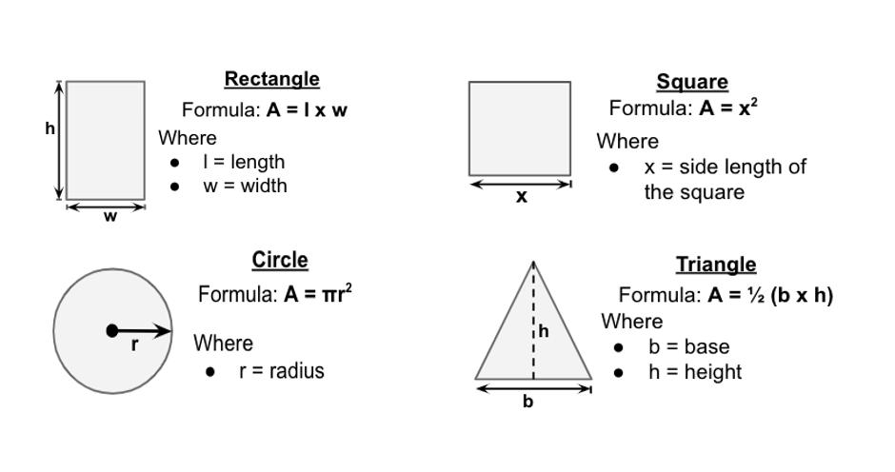
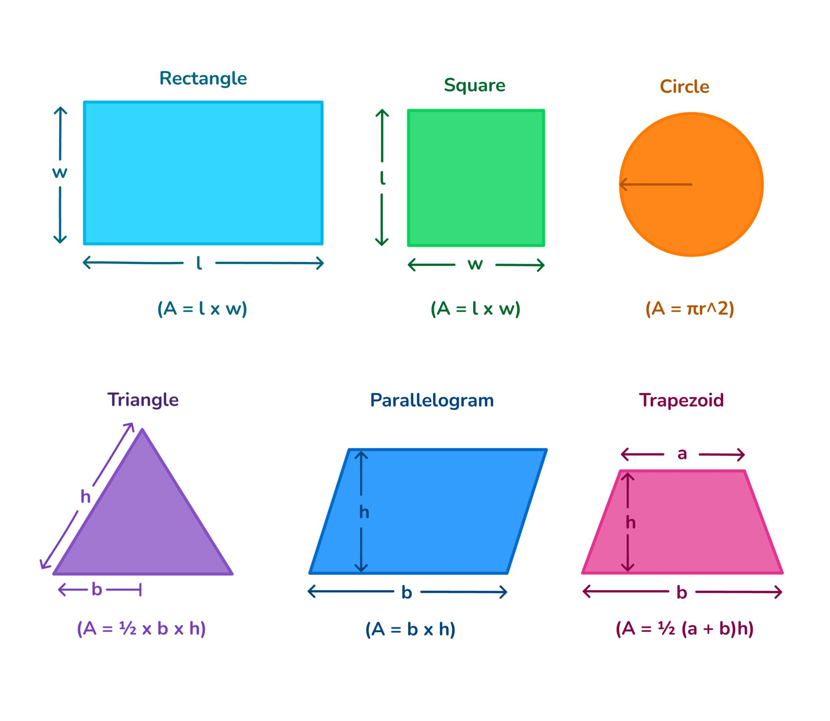
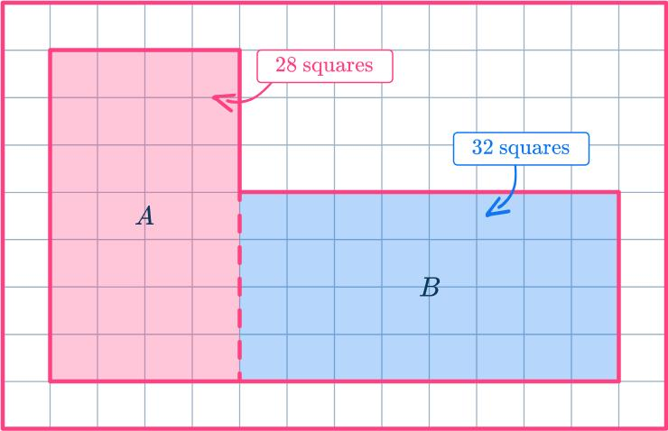
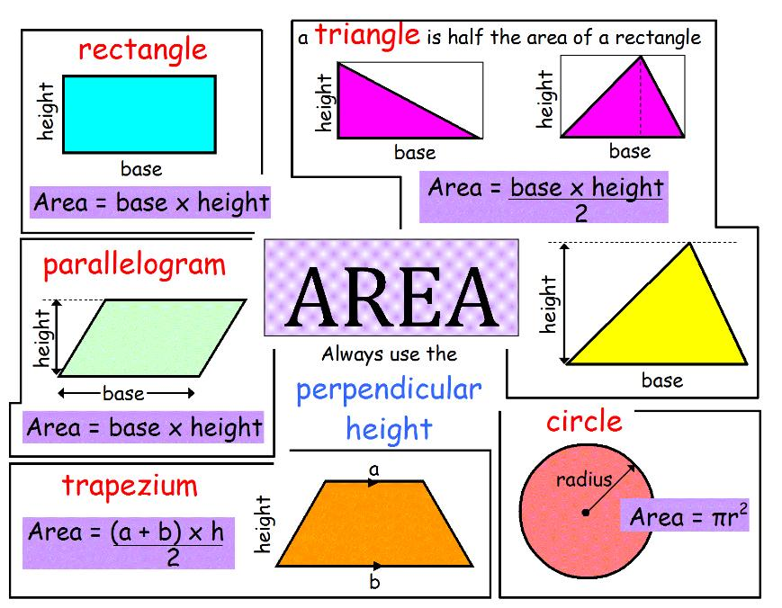
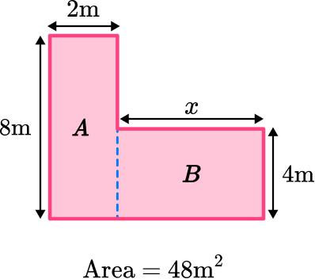

Characteristics
# Source: AI Source: Provided by: [Data Path: Persons Table -> ID Column: 1, Name_En Column: Motasem Essam] -> From: [ChatGPT] on [7/20/2026]
Area:
- Is a two-dimensional measurement.
- Measures the size of a surface or region.
- Is associated with a region, not merely a boundary.
- Is measured in square units.
- Can be calculated for regular and irregular regions.
- Is always nonnegative.
$$\boxed{A≥0}$$
Its dimensional form is:
$$\boxed{\left[A\right]=L^{2}}$$

Area and Square Units
# Source: AI Source: Provided by: [Data Path: Persons Table -> ID Column: 1, Name_En Column: Motasem Essam] -> From: [ChatGPT] on [7/20/2026]
Area can be understood by covering a region with equal-sized squares.
For example, a rectangle measuring $5$ units by $3$ units contains:
$$5×3=15$$
unit squares.
Therefore:
$$\boxed{A=15\text{ square units}}$$
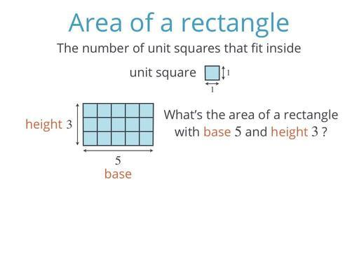
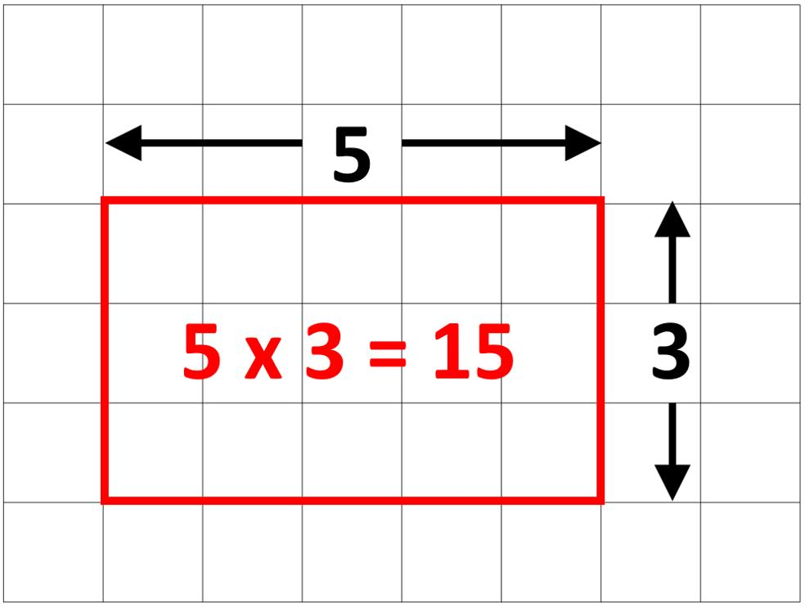
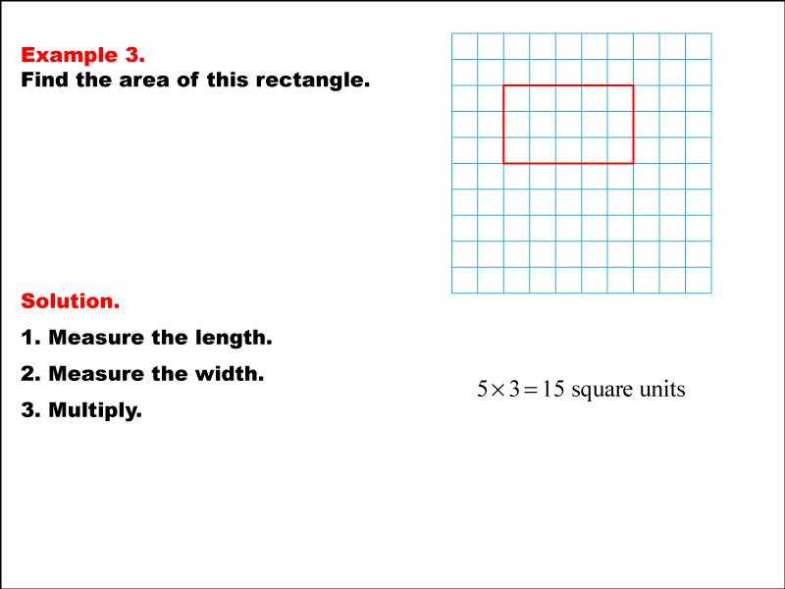

Area of Common Geometric Shapes

1. Square
# Source: AI Source: Provided by: [Data Path: Persons Table -> ID Column: 1, Name_En Column: Motasem Essam] -> From: [ChatGPT] on [7/20/2026]
For a square with side length $s$:
$$\boxed{A=s^{2}}$$
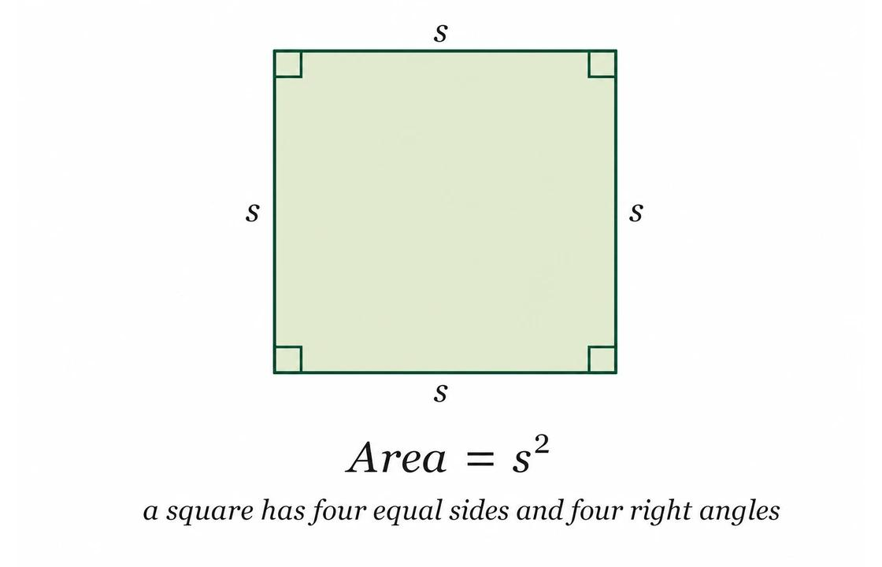
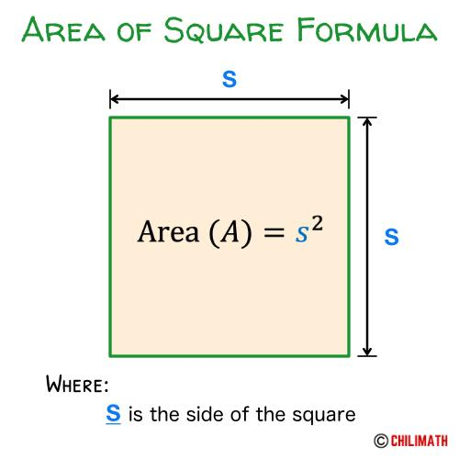
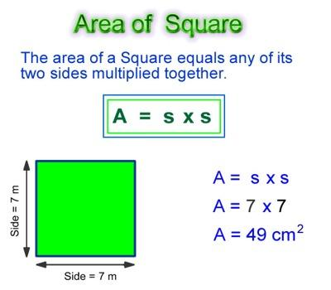
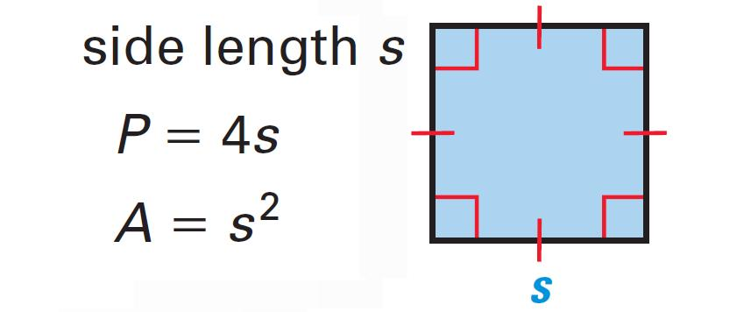
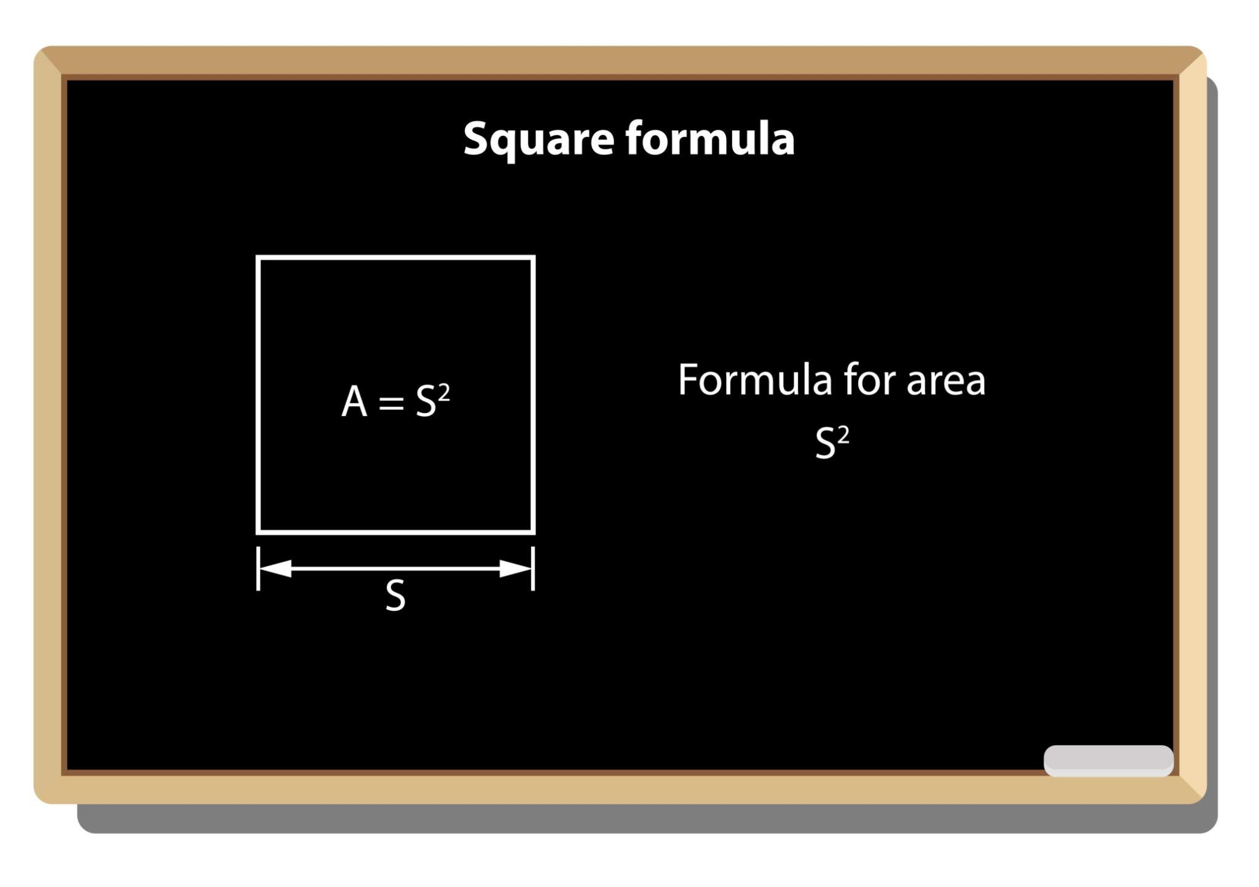

2. Rectangle
# Source: AI Source: Provided by: [Data Path: Persons Table -> ID Column: 1, Name_En Column: Motasem Essam] -> From: [ChatGPT] on [7/20/2026]
For a rectangle with length $l$ and width $w$:
$$\boxed{A=lw}$$
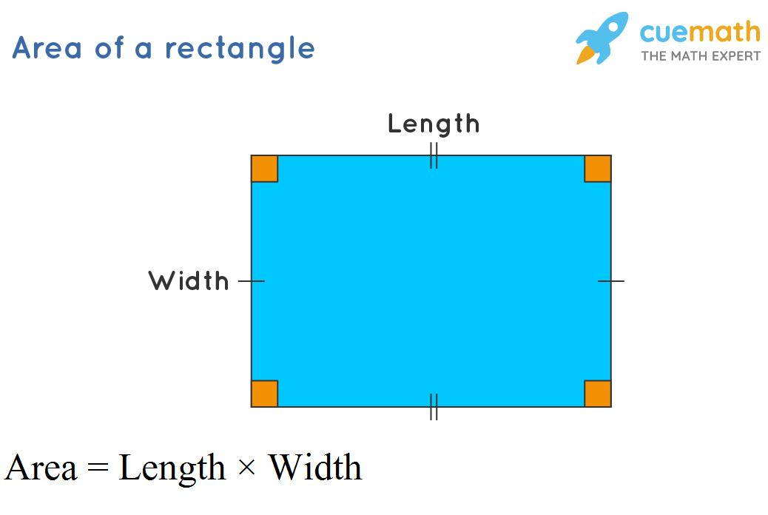
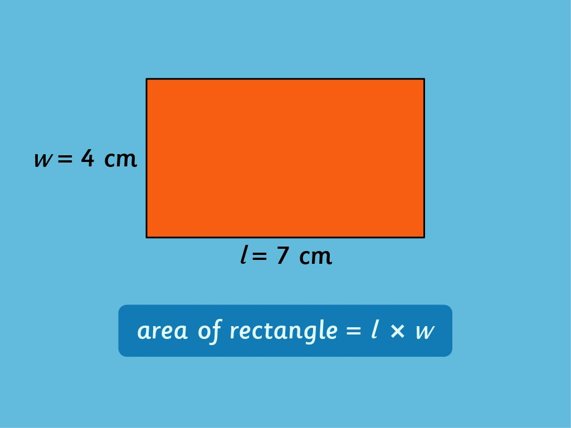
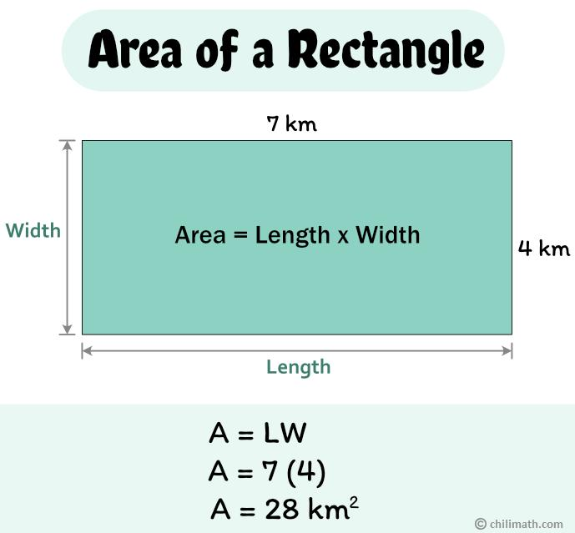
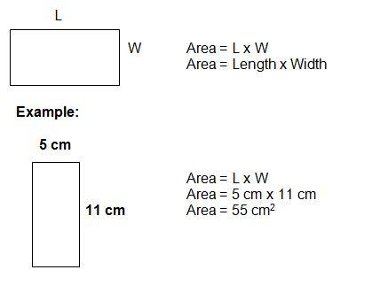

3. Triangle
# Source: AI Source: Provided by: [Data Path: Persons Table -> ID Column: 1, Name_En Column: Motasem Essam] -> From: [ChatGPT] on [7/20/2026]
For a triangle with base $b$ and perpendicular height $h$:
$$\boxed{A=\frac{1}{2}bh}$$
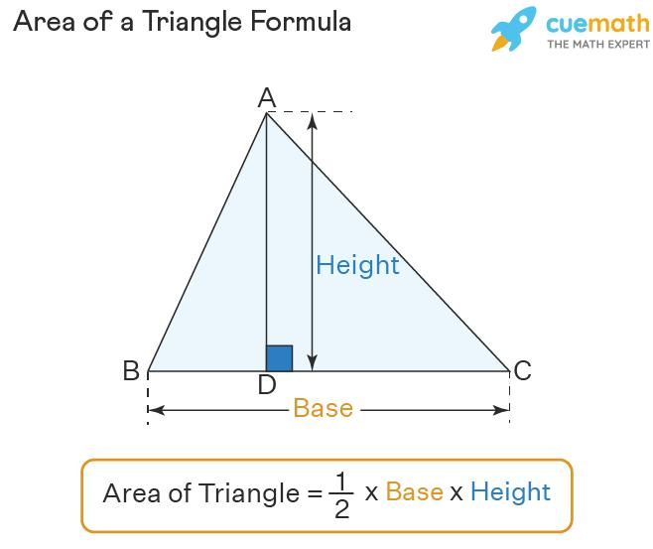
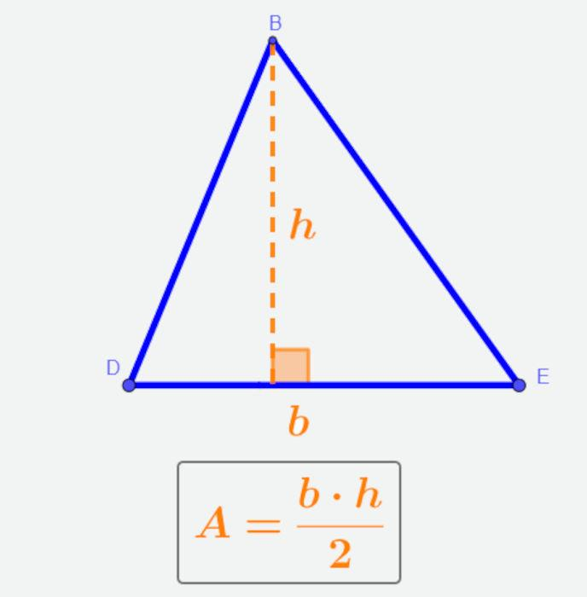
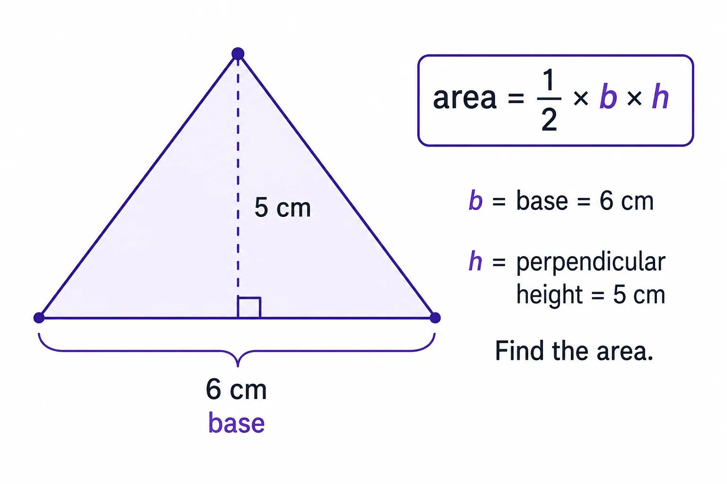
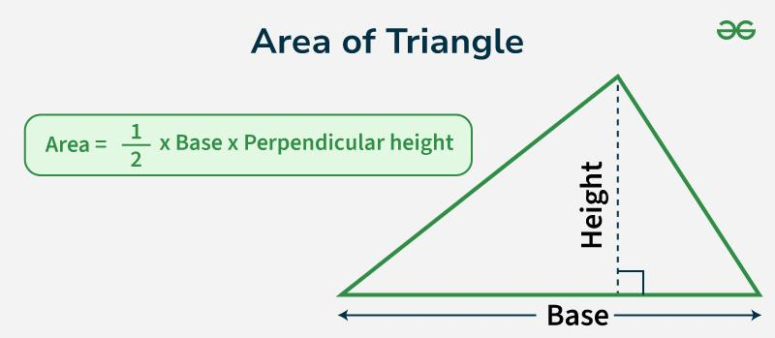
The height must be measured perpendicular to the chosen base.

4. Parallelogram
# Source: AI Source: Provided by: [Data Path: Persons Table -> ID Column: 1, Name_En Column: Motasem Essam] -> From: [ChatGPT] on [7/20/2026]
$$\boxed{A=bh}$$
where $b$ is the base and $h$ is the perpendicular height.
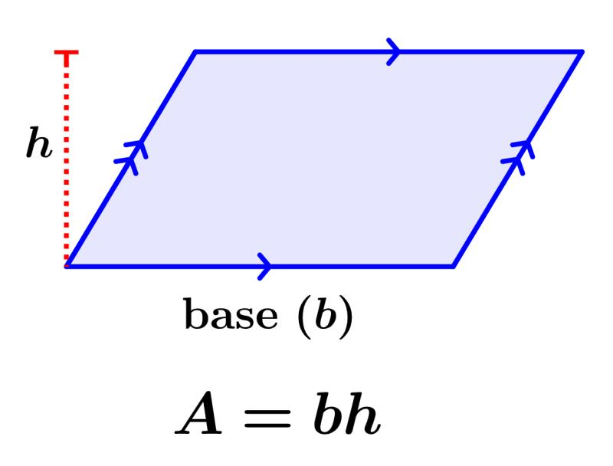
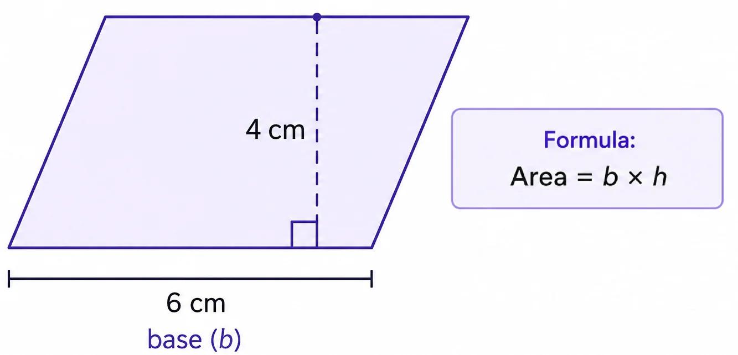
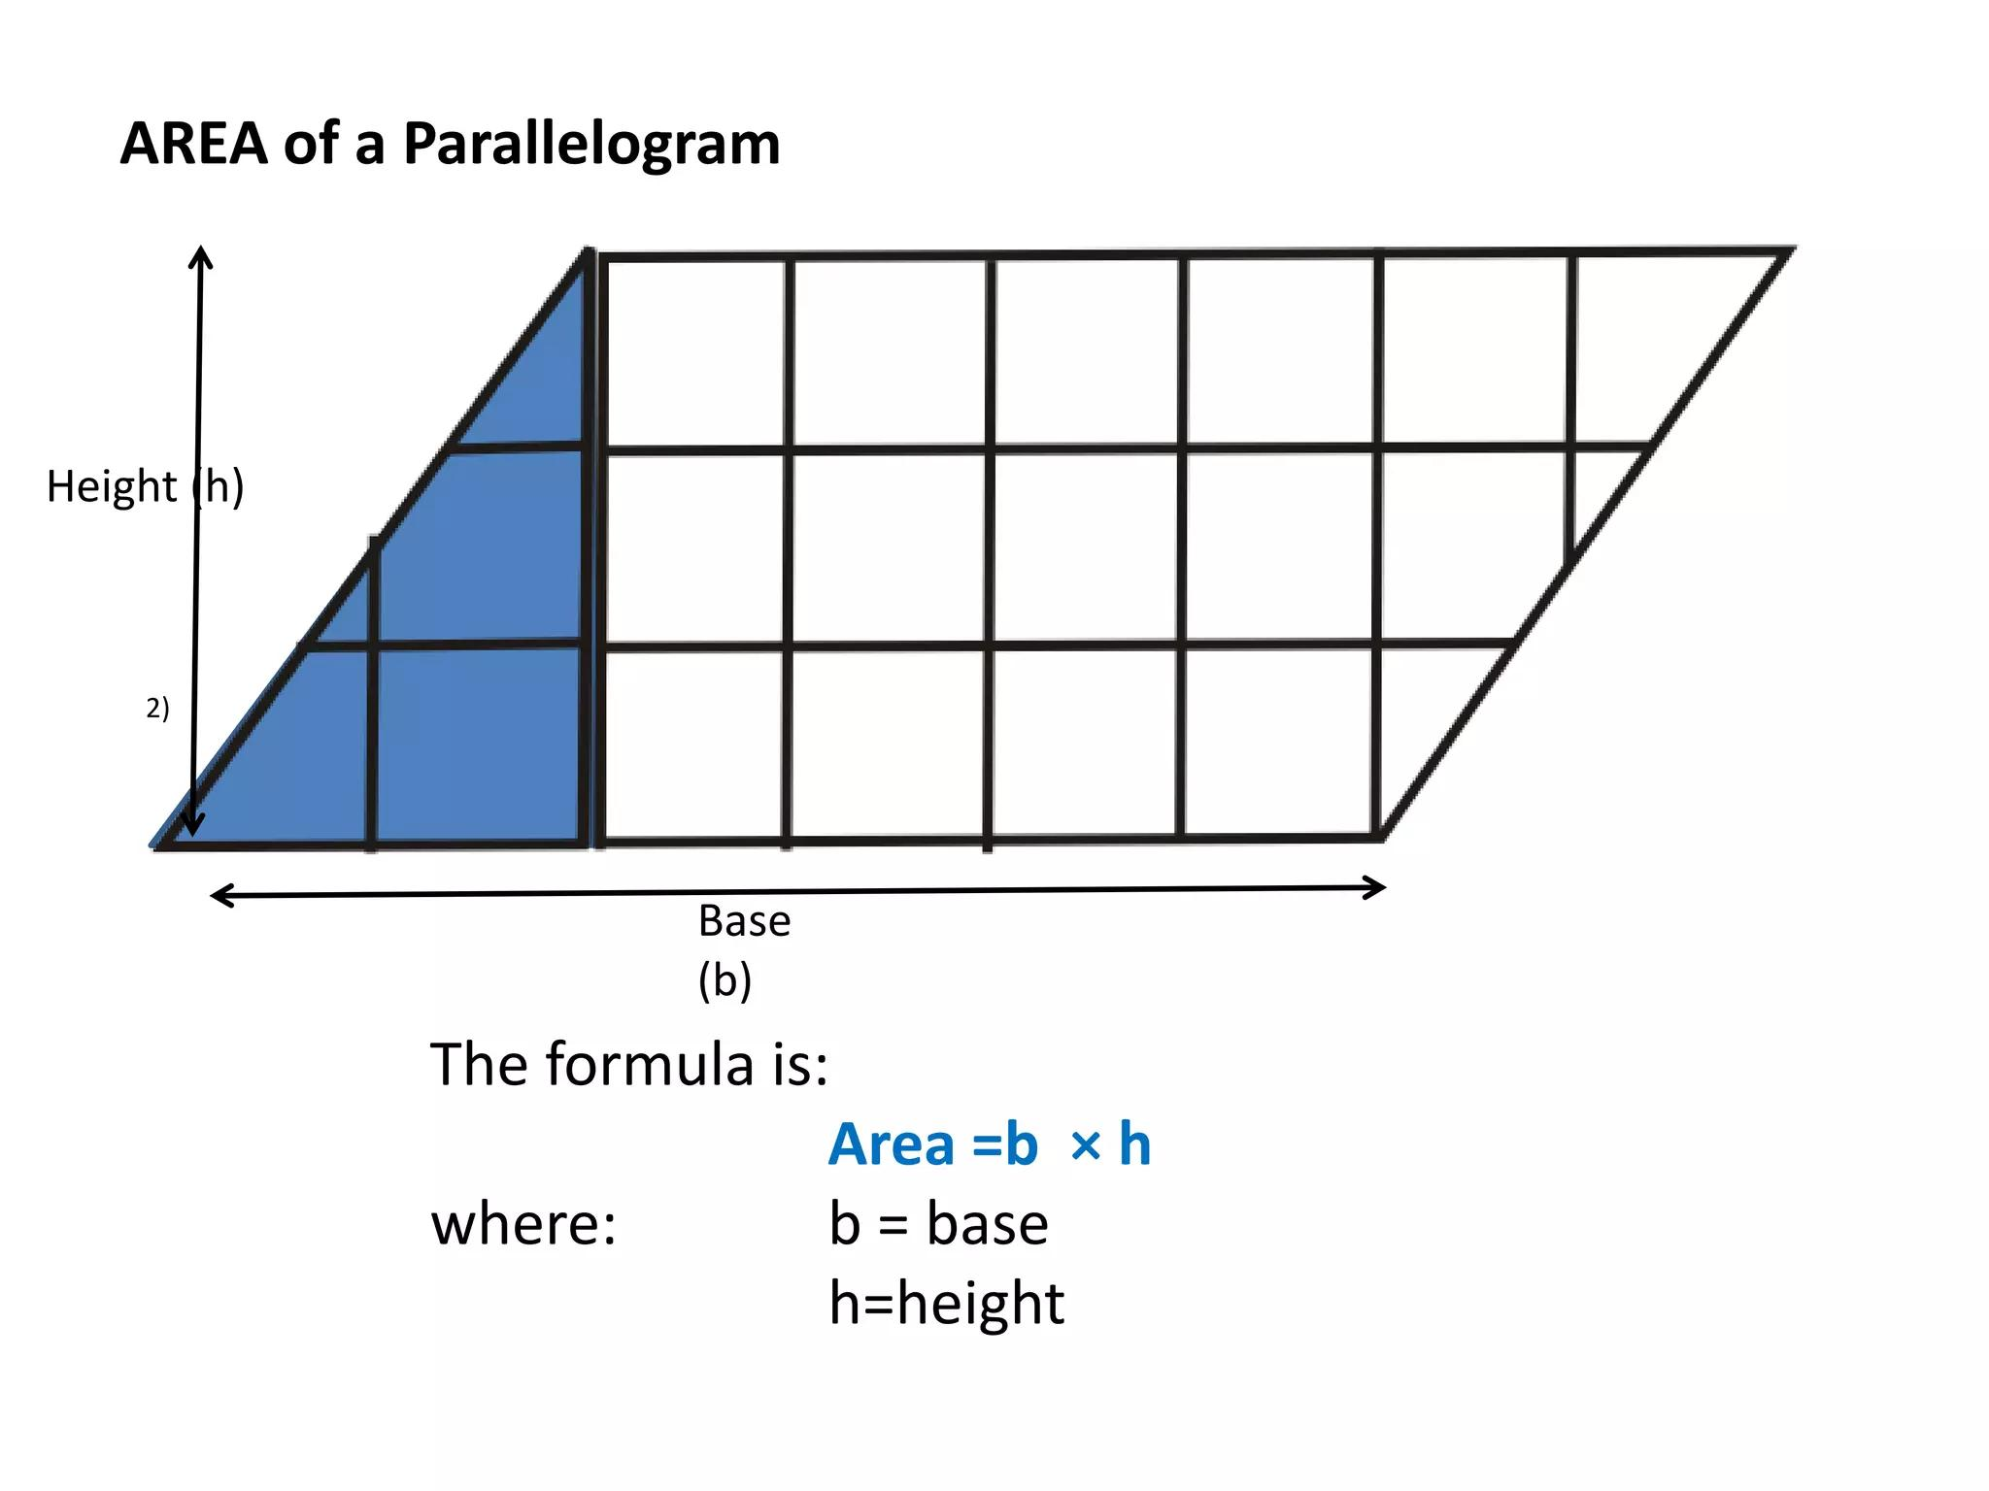
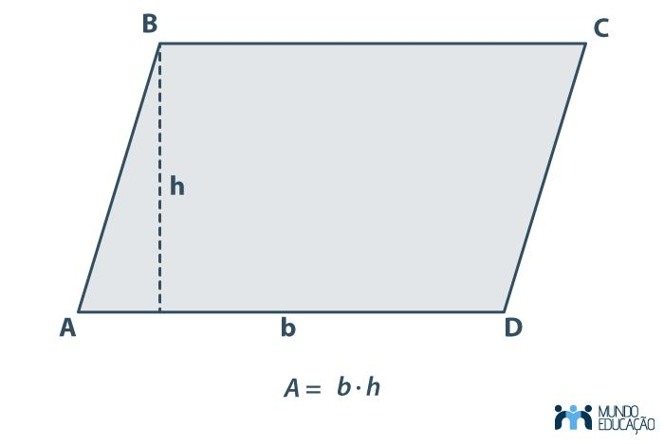

5. Trapezoid
# Source: AI Source: Provided by: [Data Path: Persons Table -> ID Column: 1, Name_En Column: Motasem Essam] -> From: [ChatGPT] on [7/20/2026]
For bases $b_{1}$ and $b_{2}$:
$$\boxed{A=\frac{\left(b_{1}+b_{2}\right)h}{2}}$$
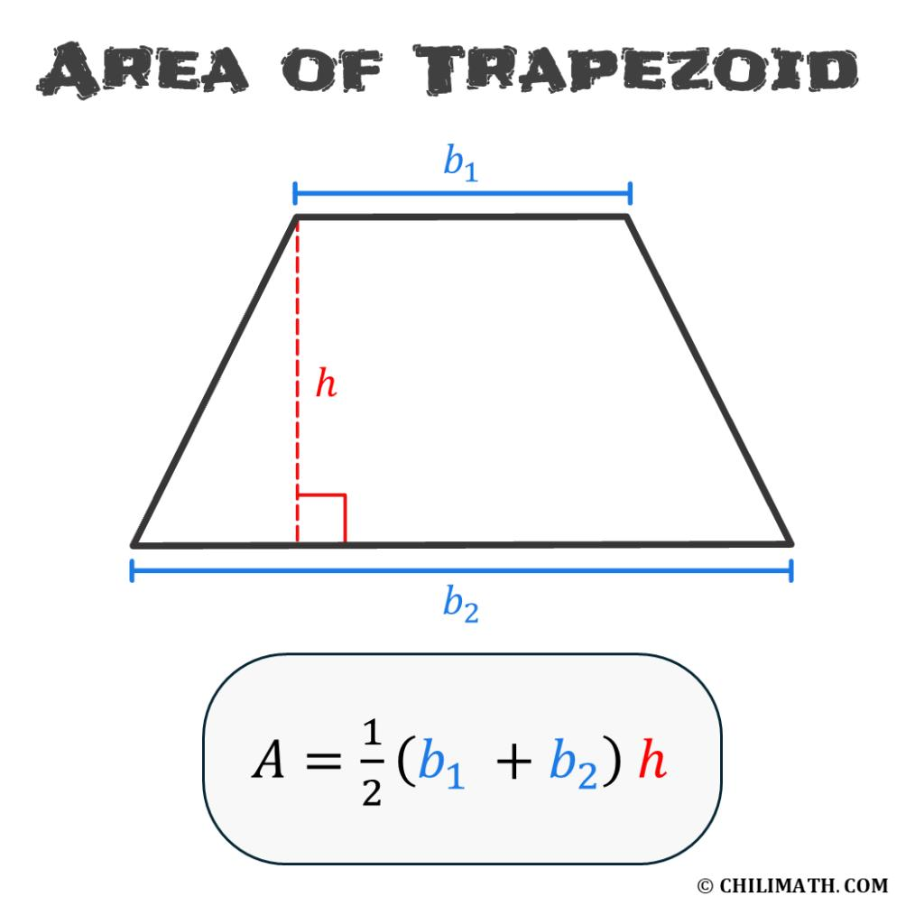
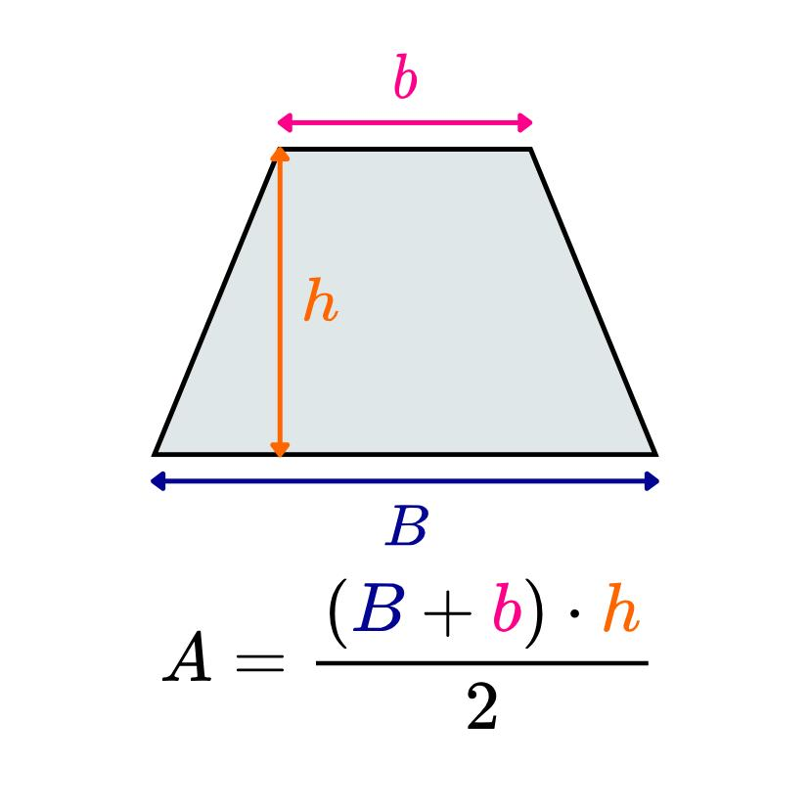
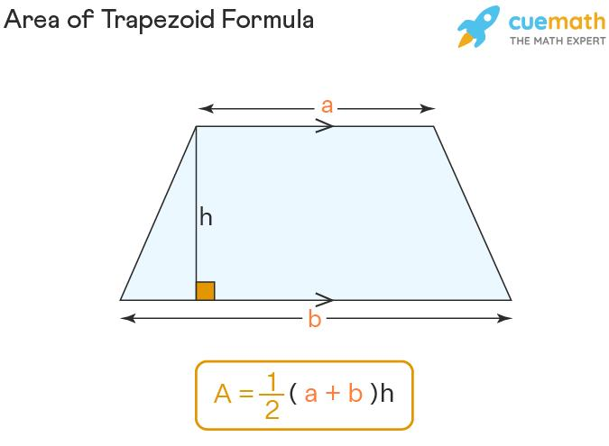
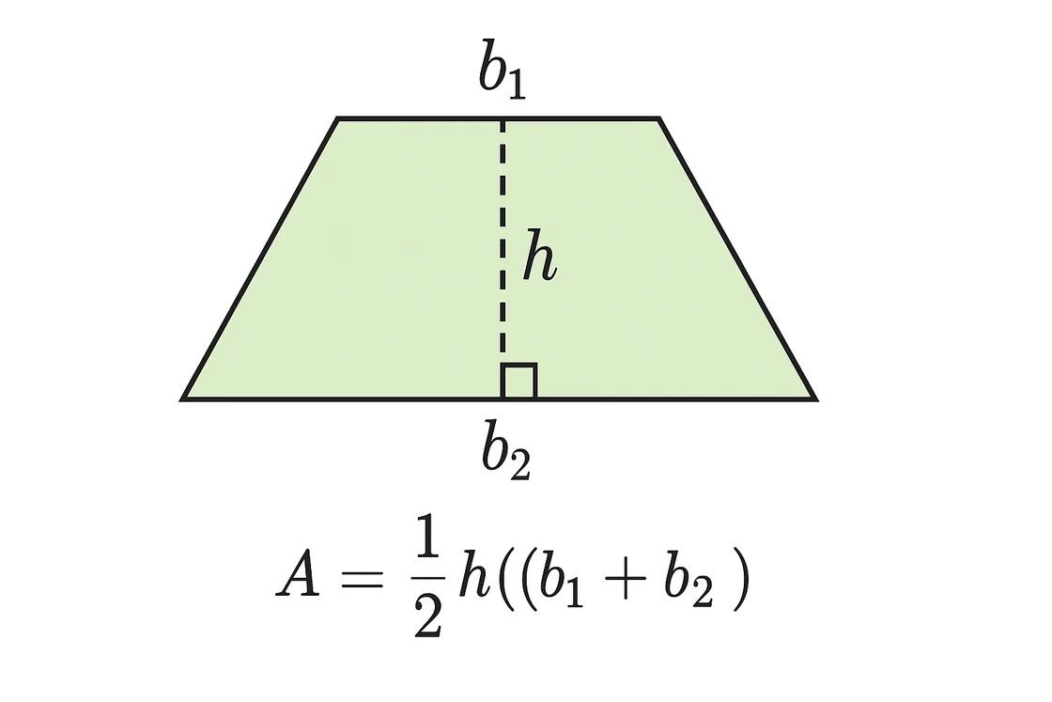

6. Circle
# Source: AI Source: Provided by: [Data Path: Persons Table -> ID Column: 1, Name_En Column: Motasem Essam] -> From: [ChatGPT] on [7/20/2026]
For a circle with radius $r$:
$$\boxed{A=πr^{2}}$$
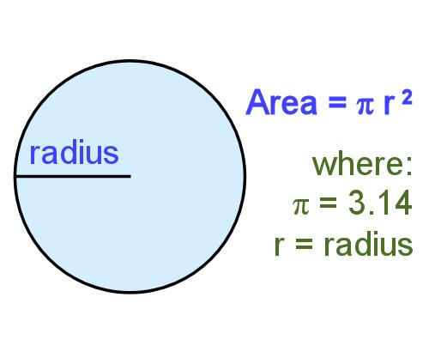
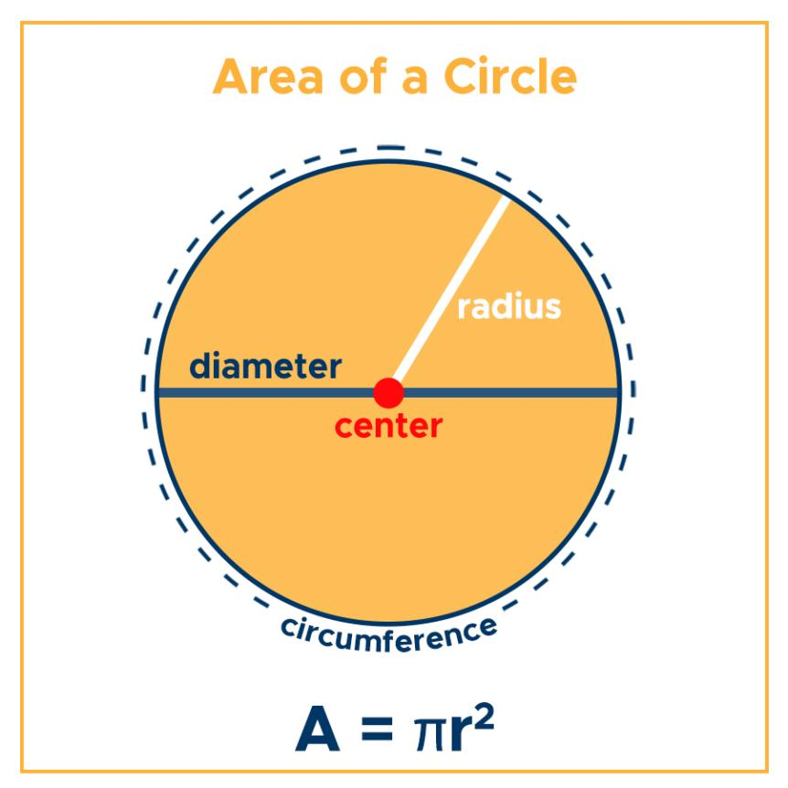
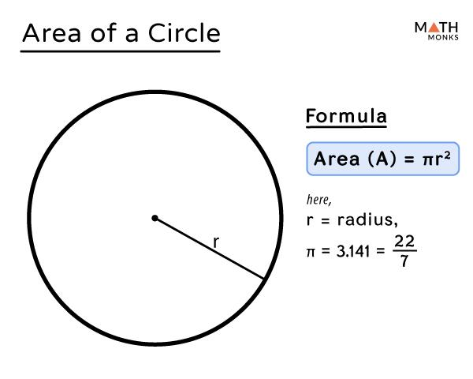
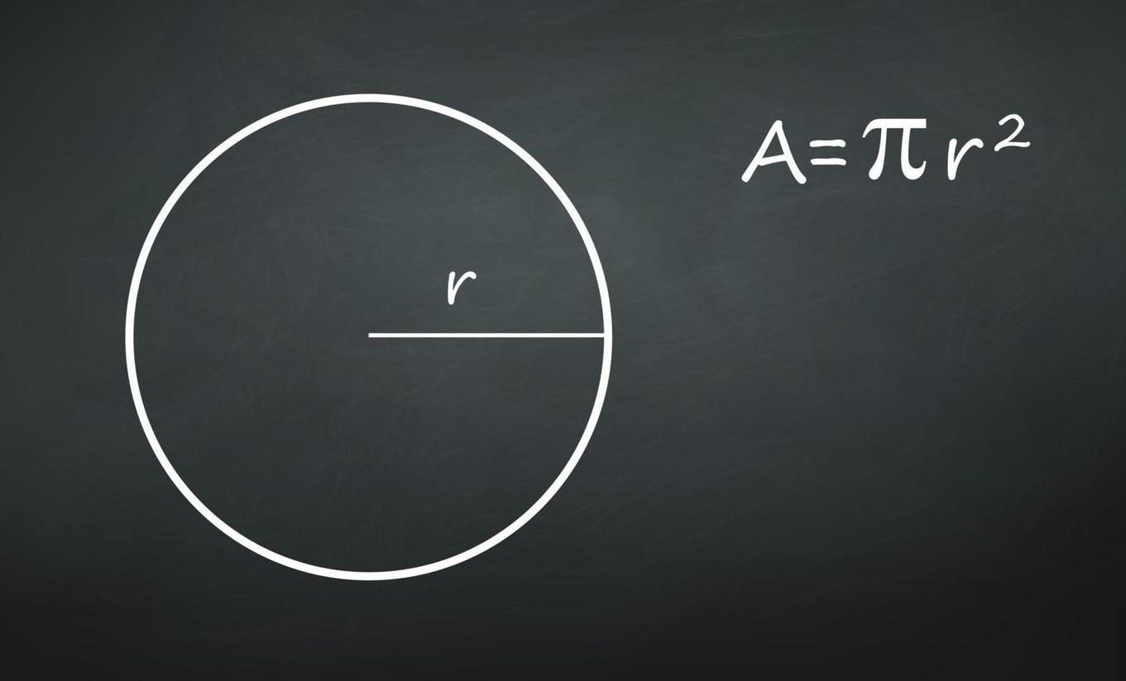

Area of Irregular Regions
# Source: AI Source: Provided by: [Data Path: Persons Table -> ID Column: 1, Name_En Column: Motasem Essam] -> From: [ChatGPT] on [7/20/2026]
Area is not limited to standard shapes.
For an irregular region, the area may be found by:
- Dividing it into simpler shapes.
- Subtracting areas from a larger known shape.
- Using a coordinate-grid method.
- Using integration for mathematically defined boundaries.
- Using numerical or computational methods.
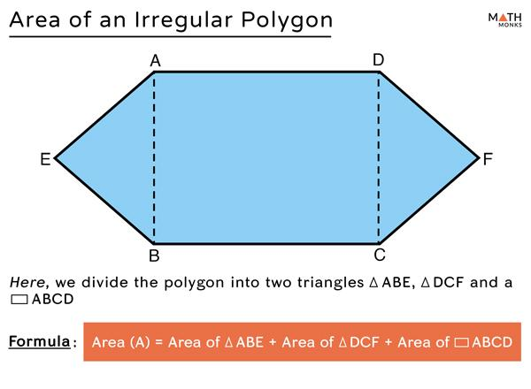
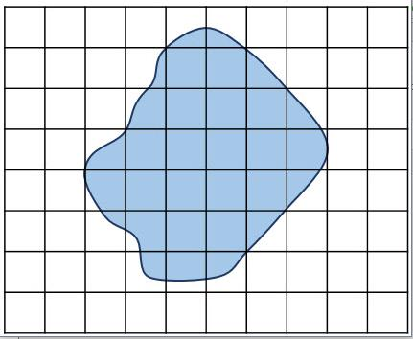
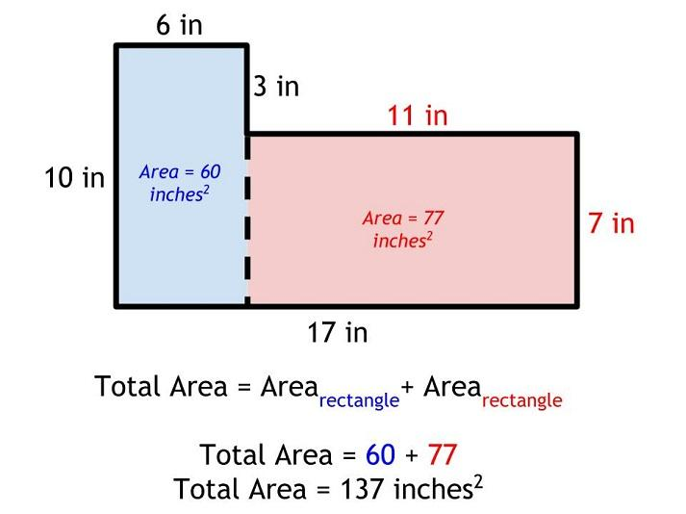
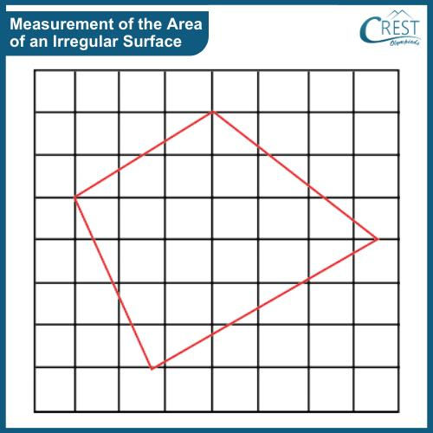
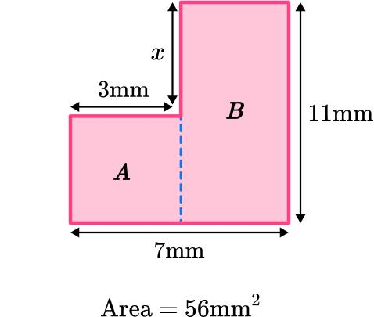
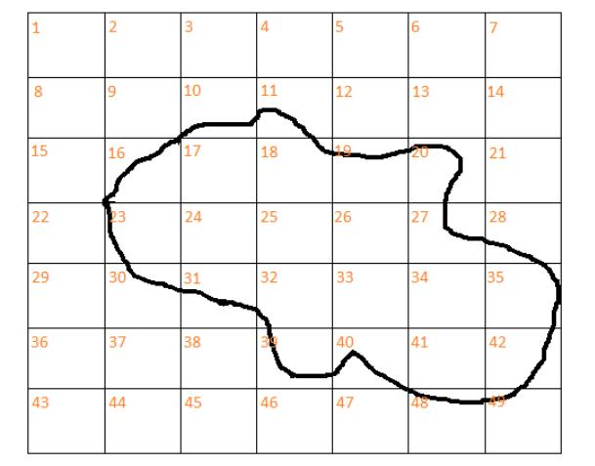
For example:
$$A_{\text{irregular}}=A_{1}+A_{2}+A_{3}$$
when the region can be divided into three non-overlapping simpler regions.

Area vs. Perimeter
# Source: AI Source: Provided by: [Data Path: Persons Table -> ID Column: 1, Name_En Column: Motasem Essam] -> From: [ChatGPT] on [7/20/2026]
These two concepts are related but measure different things.
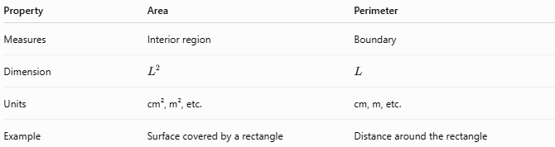
Property | Area | Perimeter
Measures | Interior region | Boundary
Dimension | $$L^{2}$$ | $$L$$
Units | cm², m², etc. | cm, m, etc.
Example | Surface covered by a rectangle | Distance around the rectangle
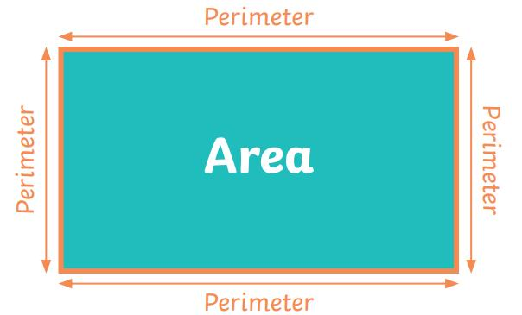
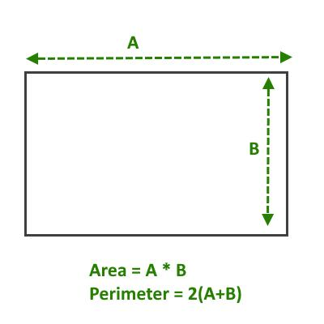
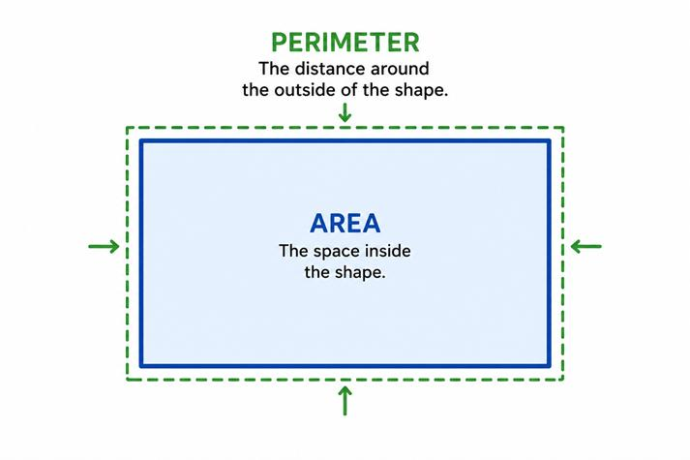
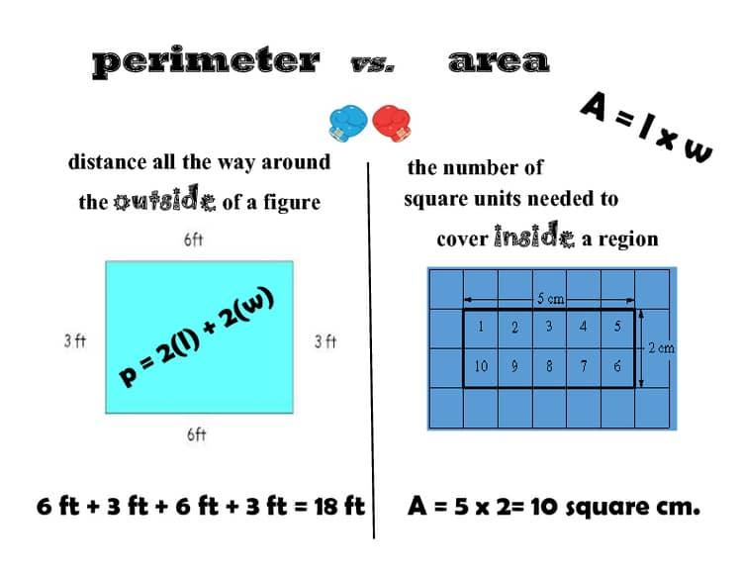
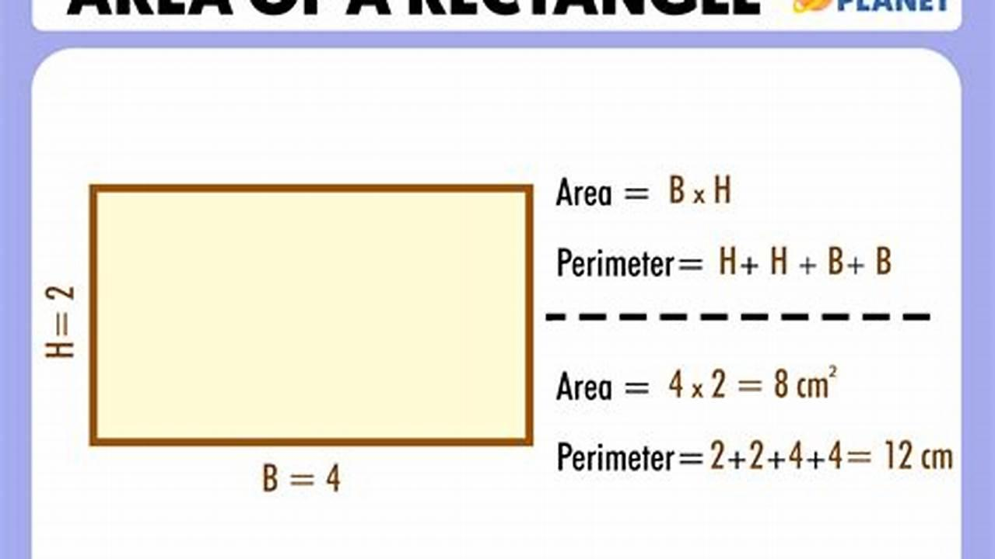
For a rectangle:
$$A=lw$$
while:
$$P=2\left(l+w\right)$$
So:
$$\boxed{\text{Area}≠\text{Perimeter}}$$

Area vs. Boundary
# Source: AI Source: Provided by: [Data Path: Persons Table -> ID Column: 1, Name_En Column: Motasem Essam] -> From: [ChatGPT] on [7/20/2026]
A boundary is the edge surrounding a region.
The area measures the region enclosed by that boundary.
Conceptually:
$$\boxed{\text{Boundary}→\text{encloses}→\text{Region}→\text{Area}}$$
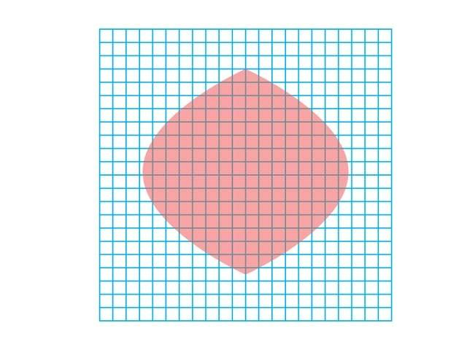
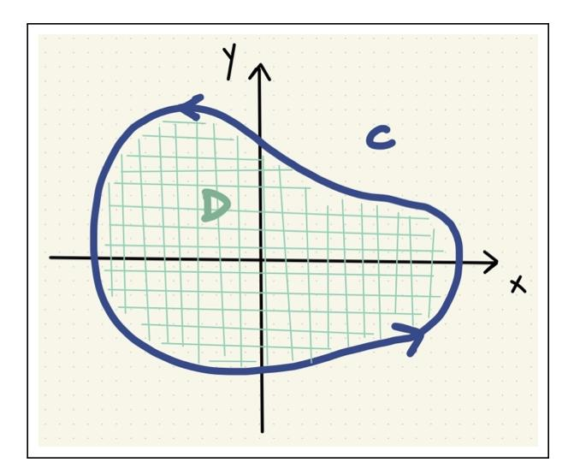
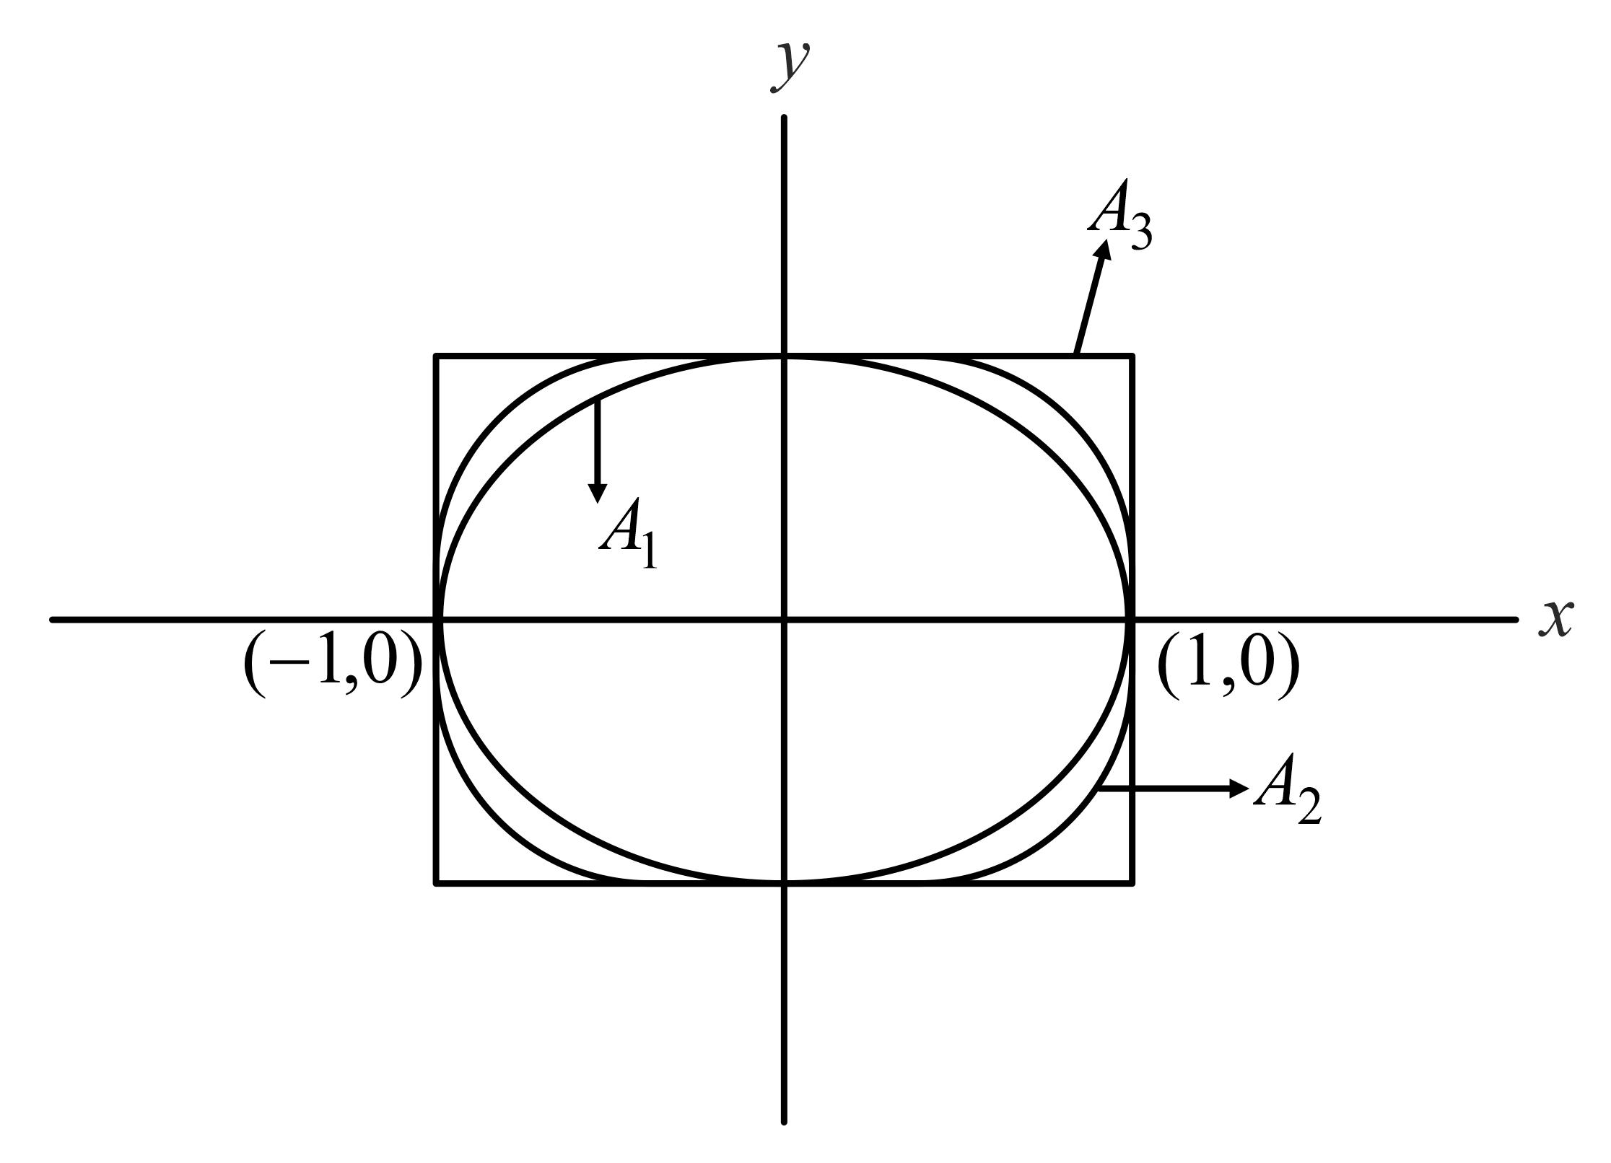
This is particularly important for your classification of closed regions, interior regions, exterior regions, and boundaries.

Area of a Composite Shape
# Source: AI Source: Provided by: [Data Path: Persons Table -> ID Column: 1, Name_En Column: Motasem Essam] -> From: [ChatGPT] on [7/20/2026]
A composite shape consists of multiple simpler geometric shapes.
Its area can be calculated by adding or subtracting component areas.
For example:
$$\boxed{A=A_{1}+A_{2}}$$
or:
$$\boxed{A=A_{\text{large}}-A_{\text{removed}}}$$

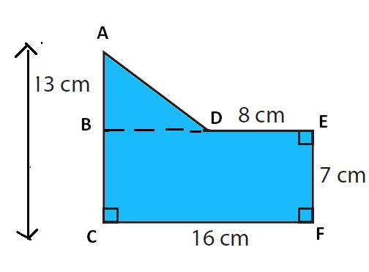
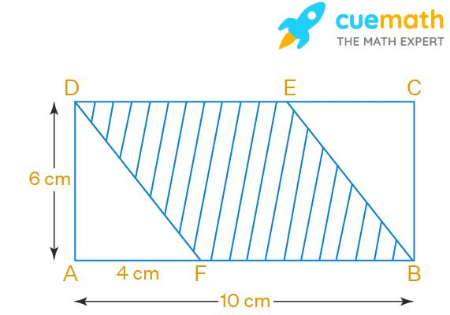
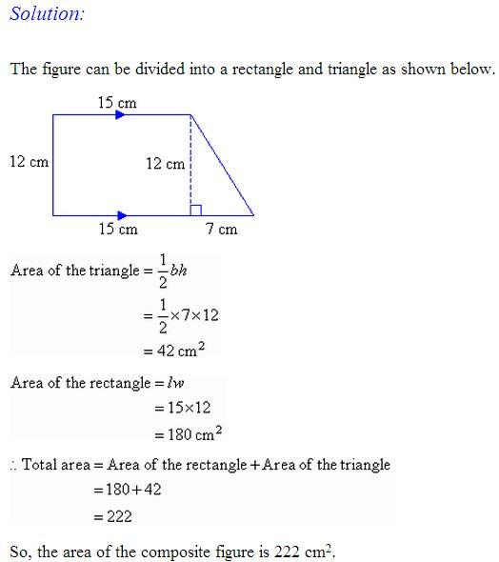
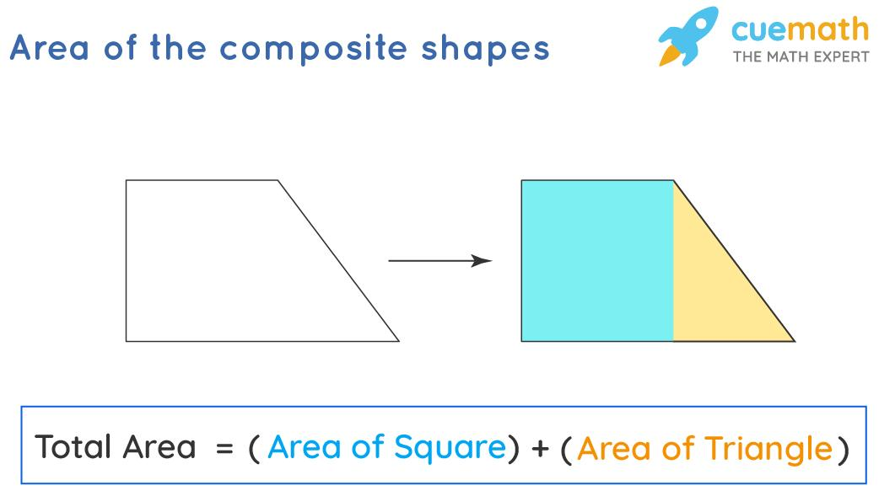

Area in Coordinate Geometry
# Source: AI Source: Provided by: [Data Path: Persons Table -> ID Column: 1, Name_En Column: Motasem Essam] -> From: [ChatGPT] on [7/20/2026]
For regions defined using coordinates, area can be calculated from the coordinates of their vertices.
For example, the shoelace formula for a polygon is:
$$\boxed{A=\frac{1}{2}\left|\sum_{i=1}^{n}{\left(x_{i}y_{i+1}-y_{i}x_{i+1}\right)}\right|}$$
with:
$$x_{n+1}=x_{1}, y_{n+1}=y_{1}$$
This is useful for irregular polygons whose vertices are known.

Area and Calculus
# Source: AI Source: Provided by: [Data Path: Persons Table -> ID Column: 1, Name_En Column: Motasem Essam] -> From: [ChatGPT] on [7/20/2026]
For a region bounded by curves, area can be calculated using a definite integral.
For example, the area between (y=f(x)) and (y=g(x)) from (a) to (b) is:
[
$$\boxed{A=\int_{a}^{b}{\left[f\left(x\right)-g\left(x\right)\right]},dx}$$]
when (f(x)\geq g(x)) on the interval.
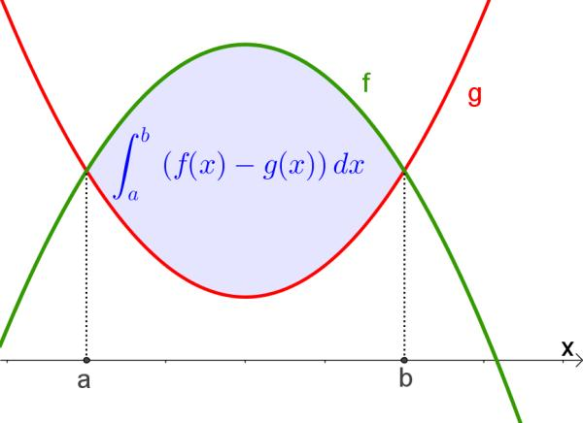
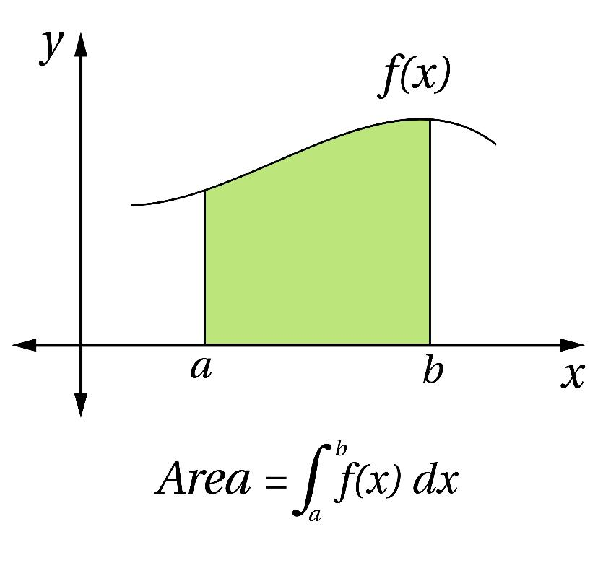
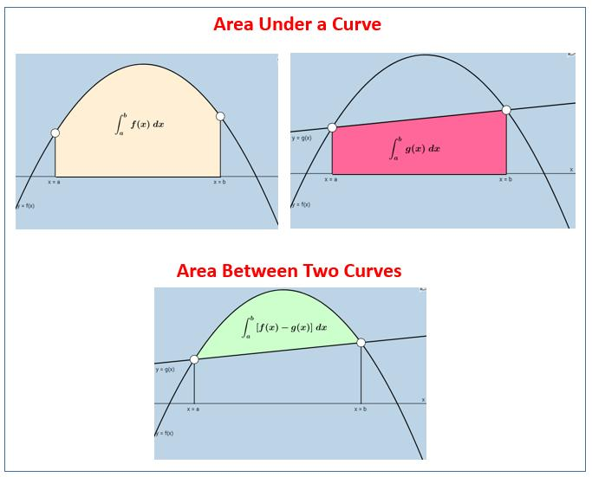
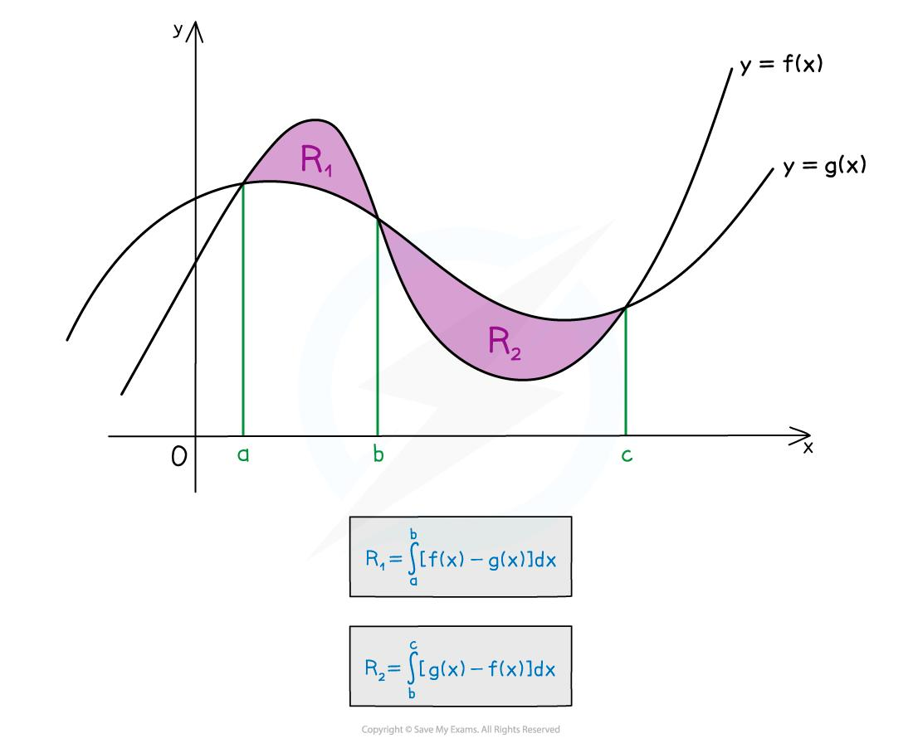
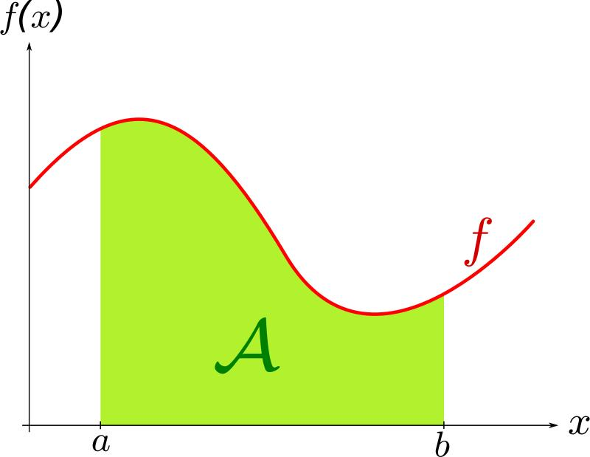

Area Units
# Source: AI Source: Provided by: [Data Path: Persons Table -> ID Column: 1, Name_En Column: Motasem Essam] -> From: [ChatGPT] on [7/20/2026]
Because area is two-dimensional, its units are squared.
Examples:
$$1{\text{ m}}^{2} \\ 1{\text{ cm}}^{2} \\ 1{\text{ km}}^{2}$$
Important conversion:
$$1{\text{ m}}^{2}=10,000{\text{ cm}}^{2}$$
because:
$$1\text{ m}=100\text{ cm}$$
and therefore:
$${\left(1\text{ m}\right)}^{2}={\left(100\text{ cm}\right)}^{2}=10,000{\text{ cm}}^{2}$$

Area and Scaling
# Source: AI Source: Provided by: [Data Path: Persons Table -> ID Column: 1, Name_En Column: Motasem Essam] -> From: [ChatGPT] on [7/20/2026]
If every linear dimension of a figure is multiplied by a scale factor $k$, its area is multiplied by:
$$\boxed{k^{2}}$$
For example, if the dimensions are doubled:
$$k=2$$
then:
$$A_{\text{new}}=2^{2}A_{\text{old}}=4A_{\text{old}}$$
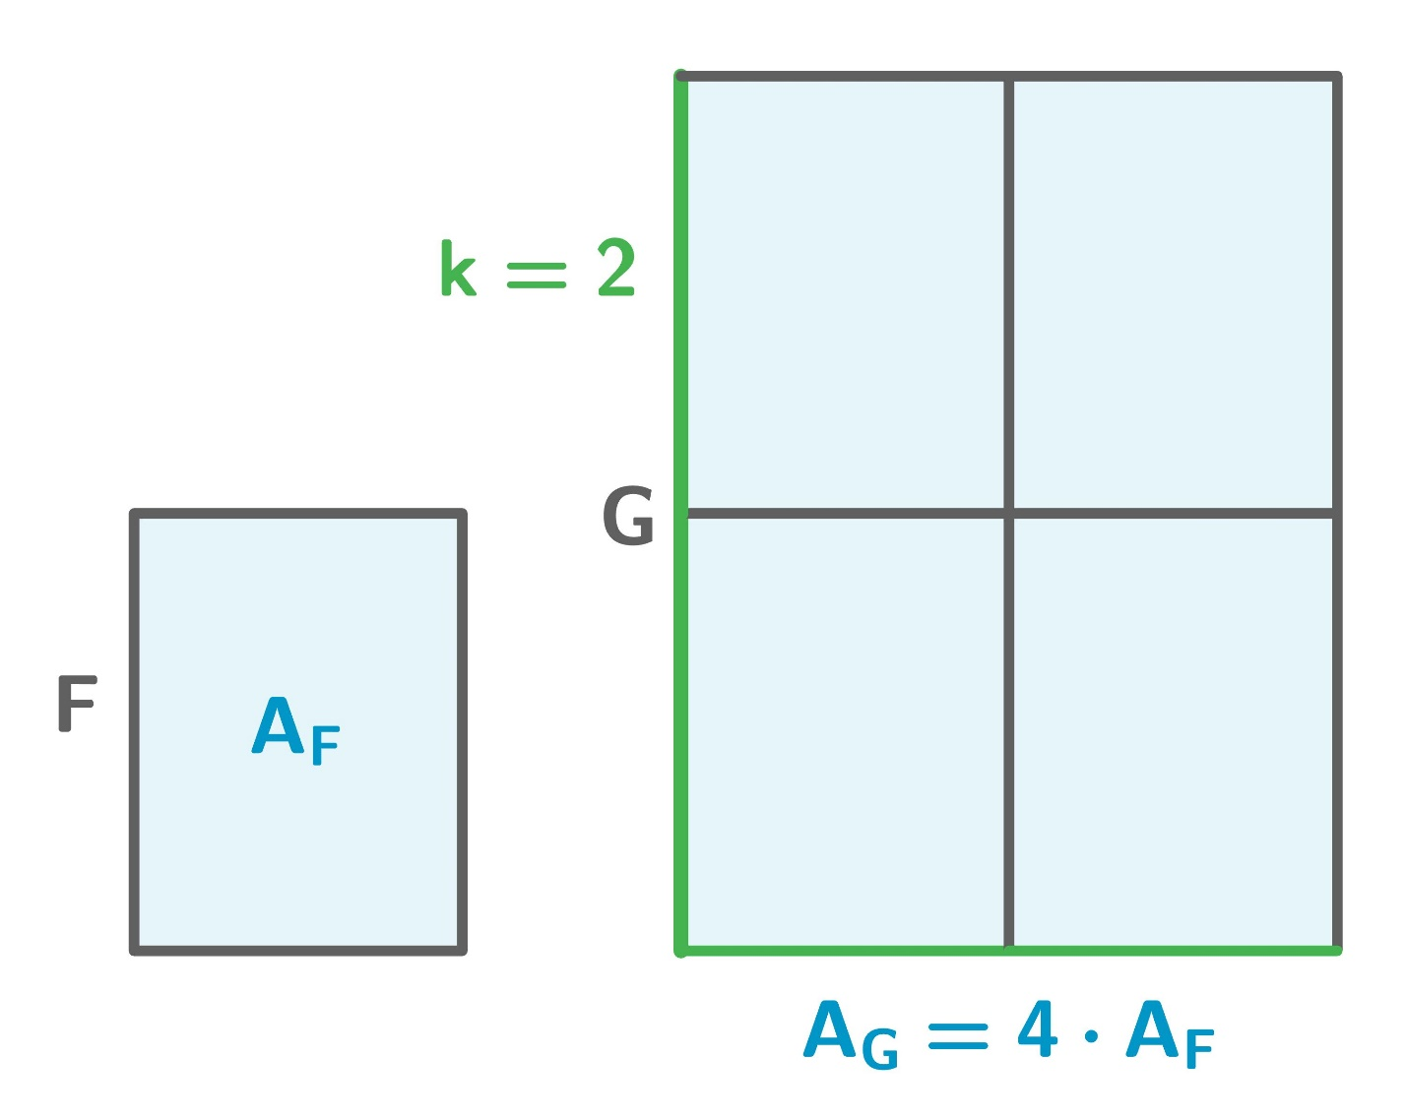
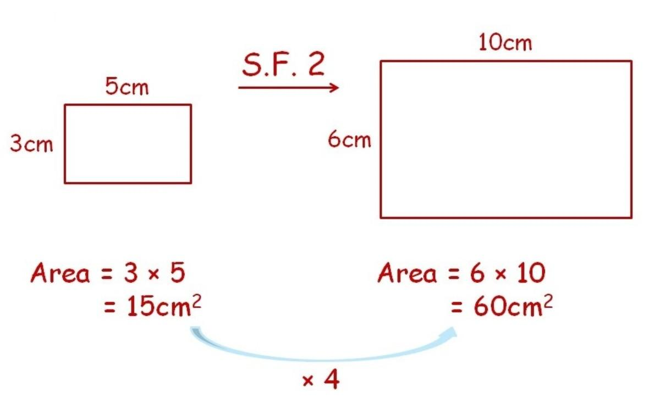
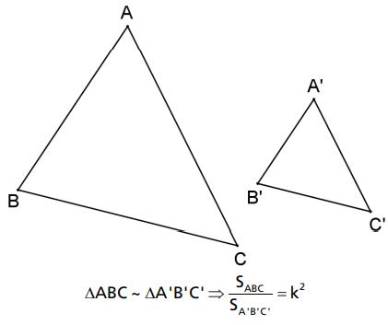
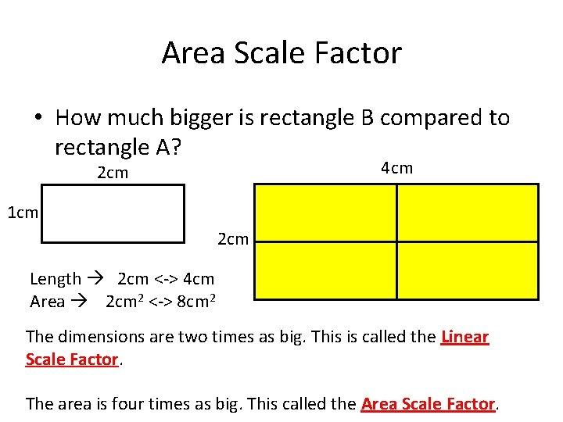
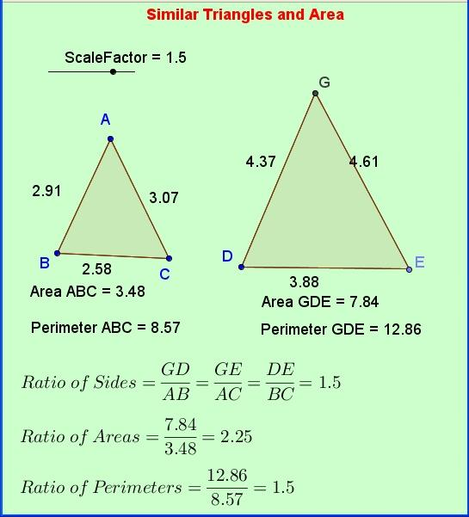
This is an important distinction from length, which scales by (k), and volume, which scales by (k^3).

Area of a Region
# Source: AI Source: Provided by: [Data Path: Persons Table -> ID Column: 1, Name_En Column: Motasem Essam] -> From: [ChatGPT] on [7/20/2026]
In your geometry classification system, area belongs naturally to the study of regions.
A useful relationship is:
$$\boxed{\text{Boundary}→\text{Region}→\text{Area}}$$
For example:
Closed Shape
→ Boundary
→ Enclosed Region
→ Area of the Region
An open curve normally does not enclose a region by itself, so it does not normally define a finite enclosed area.

Applications
# Source: AI Source: Provided by: [Data Path: Persons Table -> ID Column: 1, Name_En Column: Motasem Essam] -> From: [ChatGPT] on [7/20/2026]
Area is important in:
- Geometry
- Measurement Theory
- Engineering
- Architecture
- Construction
- Land Surveying
- Agriculture
- Manufacturing
- Mechanical Design
- Technical Drawing
- CAD (Computer-Aided Design)
- Computer Graphics
- GIS (Geographic Information Systems)
- Interior Design

Advantages
# Source: AI Source: Provided by: [Data Path: Persons Table -> ID Column: 1, Name_En Column: Motasem Essam] -> From: [ChatGPT] on [7/20/2026]
Understanding area helps to:
- Measure the size of two-dimensional regions.
- Calculate the amount of surface covered.
- Determine material requirements for surfaces.
- Calculate floor, wall, roof, and land coverage.
- Support calculations of surface area and volume.
- Analyze geometric shapes and regions.
- Support accurate engineering and architectural designs.
- Compare the sizes of different regions.

Limitations
# Source: AI Source: Provided by: [Data Path: Persons Table -> ID Column: 1, Name_En Column: Motasem Essam] -> From: [ChatGPT] on [7/20/2026]
Area:
- Measures a two-dimensional region, not a three-dimensional object.
- Does not describe the boundary length directly.
- Requires appropriate dimensions or geometric information.
- Is measured in square units.
- Does not by itself describe the object's height, depth, or volume.
- Can be more difficult to calculate for irregular regions.
- May require decomposition, coordinates, or calculus for complex shapes.

Key Points
# Source: AI Source: Provided by: [Data Path: Persons Table -> ID Column: 1, Name_En Column: Motasem Essam] -> From: [ChatGPT] on [7/20/2026]
$$\boxed{\text{Area}=\text{Measure of a 2D Region}}$$
Area:
- Measures the amount of surface covered.
- Is a two-dimensional quantity.
- Has dimensional form $L^{2}$.
- Is measured in square units.
- Is associated with regions enclosed by boundaries.
- Can be calculated using formulas, decomposition, coordinates, or calculus.
- Scales according to the square of the linear scale factor.

Conclusion
# Source: AI Source: Provided by: [Data Path: Persons Table -> ID Column: 1, Name_En Column: Motasem Essam] -> From: [ChatGPT] on [7/20/2026]
Area is the geometric measurement of the amount of two-dimensional surface contained within a region. It is fundamentally different from perimeter, which measures the boundary, because area measures the interior region itself. Area is expressed in square units and is fundamental to the geometry of polygons, circles, composite shapes, irregular regions, coordinate regions, and regions bounded by curves.

